**Vibration Motor**

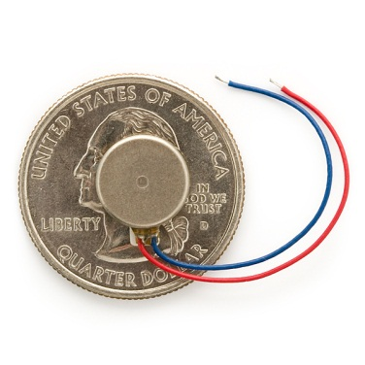

**What is Does**:Constantly vibrates when you apply a small voltage, similar to the motors in your cell phone.

**Required Connections:** Attach one wire to **Ground/GND** and the other to **Digital Output 13**.

**Using the Vibration Motor in Scratch:**

Use the digitalOn or digitalOff block to turn on and off pin 13. This will start and stop the motor.

E:\My Dropbox\PhD\IDSA Workshop\Images\digitalOn.png

Figure 1: Digital On Turns On the Motor

E:\My Dropbox\PhD\IDSA Workshop\Images\digitalOff.png

Figure 2: Digital Off Turns Off the Motor

These blocks can be chained together with a *wait* block to make the motor turn on and off every second.

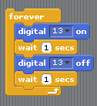

Figure 3: Turn the Motor On and Off Every Second